Aug 29, 2025 8:10 AM ET

**The Shocking True Story Behind Netflix’s *Unknown Number: The High School Catfish***



by

[Olivia B. Waxman](https://time.com/author/olivia-b-waxman/)

Staff Writer

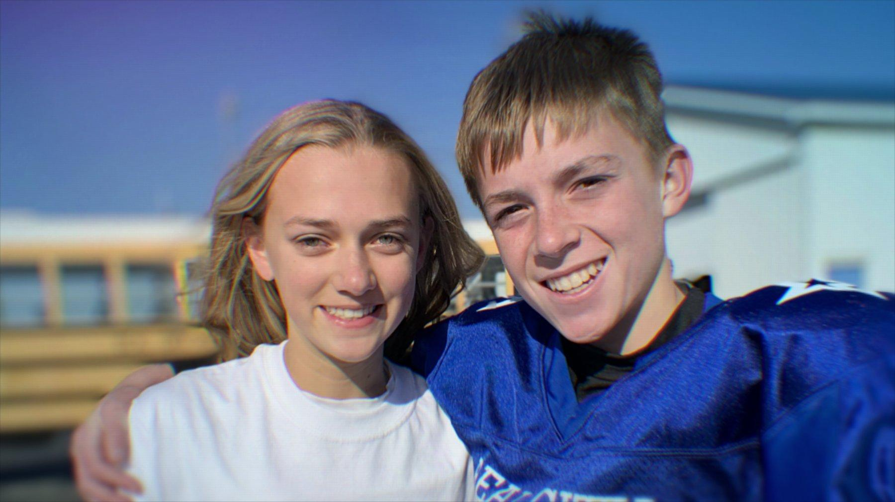

(L to R) Catfishing victims Lauryn and Owen in 'Unknown Number: The High School Catfish.' Courtesy of Netflix

*Unknown Number: The High School Catfish*, a documentary out Friday on Netflix,explores the shocking true story of a mother who [catfished](https://time.com/7086235/sweet-bobby-true-story-netflix/) her own daughter—meaning she sent hostile text messages from an unknown number, including several telling her daughter to kill herself.

In the small town of Beal City, Michigan, authorities say that starting in the fall of 2021, Kendra Licari sent aggressive text messages for over a year under an unknown number telling her daughter Lauryn and her boyfriend Owen to break up and pretending to be another classmate who was pining for him.

Advertisement

In 2023, a judge sentenced Kendra to at least 19 months in prison. Directed by Skye Borgman, *Unknown Number* features the belligerent text messages, police body cam footage of the moment Kendra was arrested, interviews with Kendra’s daughter Lauryn, her ex-boyfriend Owen, his parents, classmates and their families, school officials, local police, and the FBI liaison who took over the case.

Here are the most [shocking moments](https://time.com/7268980/good-american-family-true-story-natalia-grace/) in *Unknown Number*.

**The text messages**

The text messages looked like they were sent by a peer, saying things like, “Hi Lauryn, Owen is breaking up with you,” even though he was not. This sender repeatedly said Owen liked her better, adding, “we’re both DTF. For months she got messages like “He will be with me while your lonely ugly a** is alone.”  Many messages also called Lauryn by “Lo,” a nickname that only close friends and family used, suggesting the sender was someone in her inner circle.

Advertisement

Lauryn and Owen would call the unknown number, but no one ever picked up at the other end. Owen received as many as 30-50 messages a day from the mystery sender.

Many of the messages were extremely lewd, repeatedly telling Lauryn that Owen is going to break up with her because she was not fulfilling him sexually. One text to Lauryn read, “he wants sex, bjs n making out, he don’t want ur sry a**”, while another referred to “his dick n fingers my pussy n mouth.”

After dating for about two years, Lauryn and Owen broke up, largely because they were scared about the text messages and hoped that they would stop if they were not a couple anymore. Despite breaking up, Lauryn received a deluge of messages like “kill yourself now b****”, “his life would be better if you were dead”, and “DEAD #bangbang #suicide.”

**How the mom got caught**

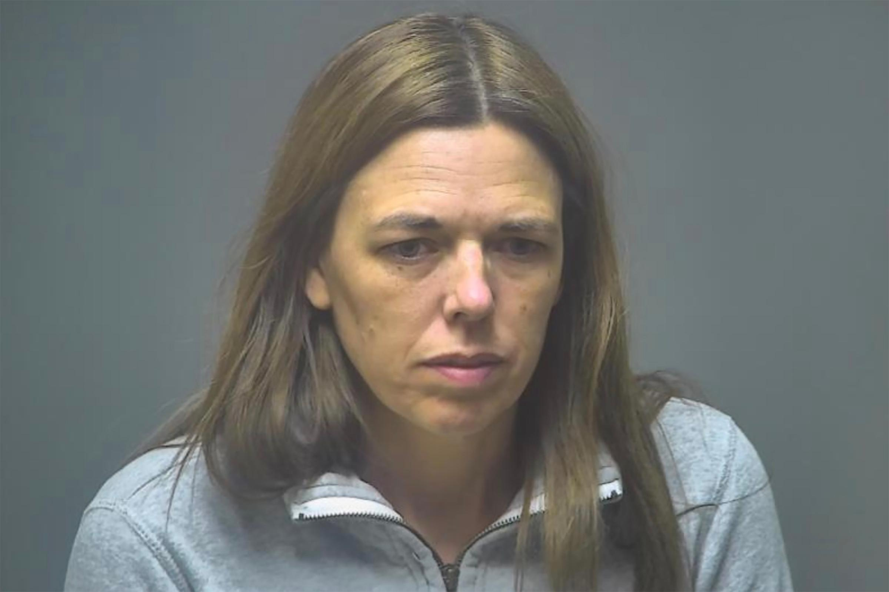

Kendra Licari. Isabella County Sheriff’s Office

Advertisement

The local authorities got involved in January 2022 and called in the FBI for reinforcements a few months later in April.

The FBI liaison working on the case, Bradley Peter, explains in the documentary that he was able to figure out that some of the text messages were sent through an app that disguises phone numbers.

When he submitted a search warrant to the app, he saw some numbers from Verizon. After submitting another search warrant to Verizon, he saw that Kendra Licari’s number kept popping up.

The local sheriff was puzzled by this because Kendra had been repeatedly checking in with authorities about the status of their investigation into the source of the text messages.

Viewers will see body cam footage of the moment that police showed up at Kendra’s house to arrest her and seize her tech devices in December 2022. In that moment, she is very cooperative with the police, and Lauryn stays close to her mother in mostly stunned silence.

Advertisement

**Why the mom catfished her daughter**

In the documentary, Kendra Licari tries to argue that everyone makes mistakes, herself included, stating, “Realistically, a lot of us have probably broken the law at some point or another and not gotten caught. I’m sure people drove drunk, haven’t been caught.”

One reason Kendra had time to send these text messages is because she did not have a full-time job. The documentary reveals that though she’d claimed to her husband Shawn that she’d quit her job, she was actually let go and never lined up any other kind of work.

In the documentary, Owen and his mother question if Kendra was secretly attracted to him. Owen says she’d cut up his steak into bite-sized pieces when he was dating Lauryn and frequently checked in on him one-on-one to ask how he was doing. Plus, she was always going to his sporting events, even after he and Lauryn broke up. Kendra is not asked to respond to these accusations in the documentary.

Advertisement

But she argues that her behavior stems from previous trauma that she hadn’t processed and opens up about how she was raped at 17.

“As my daughter was hitting those teenage years, I got scared,” she says in the documentary. “I was afraid of letting her grow up, want[ed] to protect her and keep her safe.”

When asked what she thought of Kendra’s response, Borgman told TIME: “I don't think what Kendra is saying is that she was afraid Owen was going to rape Lauren. Her fear was having her little girl grow up and go out into this big, bad world. She did these things to keep Lauren closer, to have Lauren come to her for help. By sending these text messages, she was essentially forcing Lauren closer to her.”

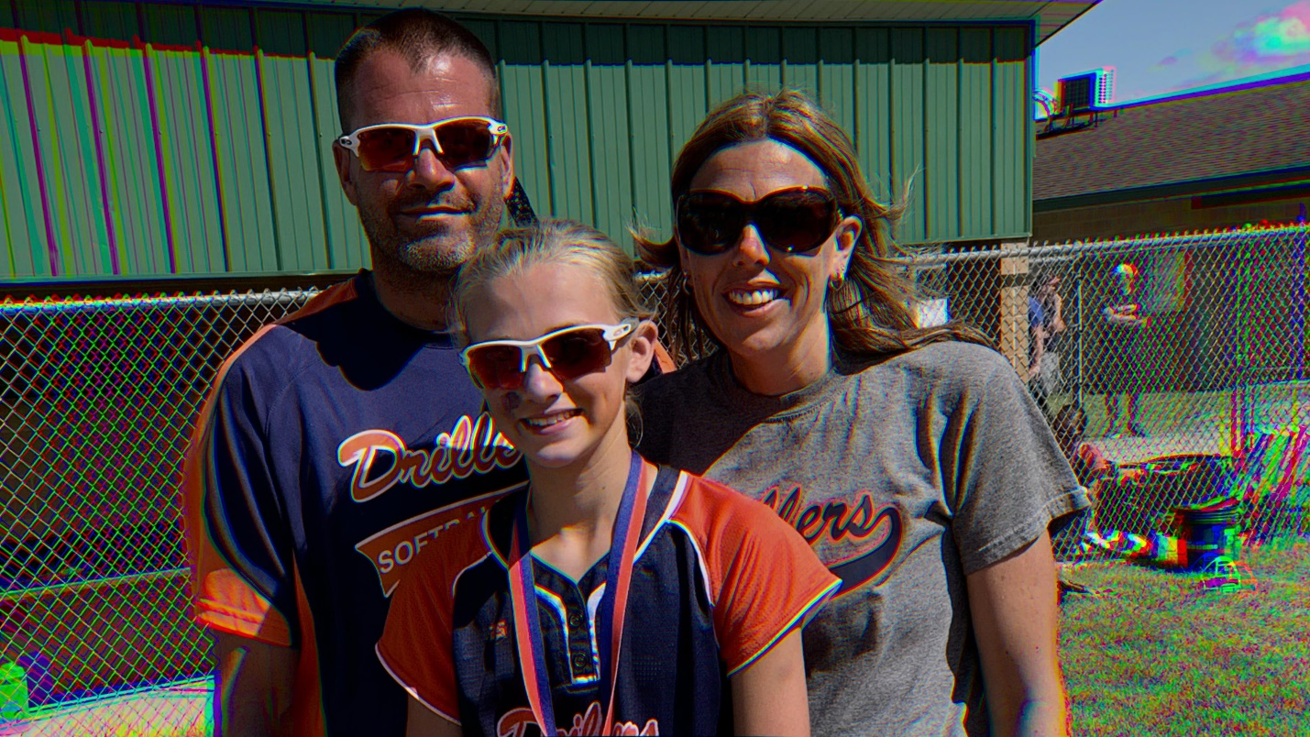

A family photo from the Netflix doc 'Unknown Number: The High School Catfish' shows Kendra Licari (right) who catfished her daughter Lauryn (center). At left, Kendra's husband Shawn. Courtesy of Netflix

Advertisement

In the documentary, when Borgman asks why Kendra did what she did, she says, “I was not scared of her hurting herself.” Borgman believes it is still unclear why Licari sent her daughter text messages encouraging her daughter to commit suicide.

“I do not have an answer for you. I asked her that in the documentary, you hear the question. And she doesn't have a good answer,” Borgman says. “Maybe the escalation to telling Lauryn to kill herself is the last attempt to get her as close as she possibly can. But it just seems so incredibly extreme. I mean, she says she never thought Lauren would do it, but I just don't know any parent who would ever even think of doing something like that.”

The former Beal City superintendent, Bill Chillman, says in the documentary that Kendra had the cyber version of Munchausen syndrome, arguing, “She wanted her daughter to need her in such a way that she was willing to hurt her, and this is the way she chose to do that versus physically trying to make her ill, which is typical Munchausen behavior.”

Advertisement

In an interview for the doc, Kendra is asked whether the text messages calling her daughter anorexic reflected her own insecurities and whether she was really just texting herself. “Possibly,” Kendra replies, “because I was way too thin. I was not eating. So you could put me in that anorexic category.”

Even after doing the documentary, Borgman doesn’t believe it’s clear why Kendra started sending aggressive text messages to her daughter, arguing, “I don't know that we're ever going to understand that fully. I think it's going to take a lot of work on Kendra's part to figure that out, some real big self-reflection.”

**Kendra and Lauryn’s relationship now**

Lauryn has graduated high school and is 18 years old, so she’s free to establish any kind of relationship with her parents. She’s closer to her father Shawn than ever before, and the documentary shows them spending a lot of quality time together on nature walks.

Advertisement

When Borgman interviewed Lauryn in 2023, it was shortly after her mom went to prison, and she missed her mom a lot. Kendra and Lauryn stayed in touch throughout her prison sentence. But when the filmmakers interviewed Lauryn again in 2024, she had changed her mind about wanting to stay close to her mother. As Bergman puts it, “She didn't hate her mother at all, but she was a little bit more measured in communications with her and a little bit more measured about how much she was willing to let Kendra into her life.”

At the end of the documentary, Kendra is out of prison and hasn’t seen Lauryn for a year and a half. Lauryn is not ready to see her mom yet. As screenshots of the cruel text messages that Kendra sent Lauryn flash across the screen, Lauryn says, “Now that she’s out, I just want her to get the help she needs, so when we see each other, it doesn’t go back to the old ways and the way it was before.” Lauryn gets the last word in the doc, saying, “I love her more than anything.”

Advertisement

*If you or someone you know may be experiencing a mental-health crisis or contemplating suicide, call or text 988. In emergencies, call 911, or seek care from a local hospital or mental health provider.*